Department of Education

Sie Web Services

October 15, 2010

Abner García
Technical Leader

www.Intelutions.net

Change Control

Versión |  | Día |  | Autor |  | Descripción
1.0 | Dec/13/2010 |  | Abner García |  | Document Created
1.1 | Dec/14/2010 |  | Abner García |  | Modify document properties and document structure.
1.2 | Dec/20/2010 |  | Fernando Carderón |  | Added modifications to XML Schema to represent more than one Student Parent.
1.3 | Dec/20/2010 |  | Abner García |  | Implement recommendations made by Fernando Carderón and add the Error Codes and Messages.
1.4 | Dec/27/2010 |  | Abner García |  | Add SIES Web Service snapshots and update the XML messages.
1.5 | Jan/17/2010 |  | Abner García |  | Update the StudentResponse XML message to support many schools.
2.0 | Feb/08/2010 |  | Abner García |  | Update the StudentResponse XML message with new fields.
2.0 | Jun/2/2011 |  | Abner García |  | Review and insert SIE database table’s definition.
3.0 | Nov/15/2011 |  | Luis Suárez |  | Add SIES Web Service new Web Method and new the XML messages (Schools, CTE, Student Classes, Teacher Classes and Transcripts).
3.5 | Apr/17/2011 |  | Luis Suárez |  | Add SIES Web Service new Web Method and new the XML messages (Student Search). Added the changes to the existing Web Method.
4.0 | Oct/22/2012 |  | Abner García |  | Update the existing XML messages specifications and text format. Add SIE Security details and specifications.
4.1 | Oct/29/2012 |  | Abner García |  | Update content with the Fernando’s comments.

Reviewers

Name | Version Approved |  | Position | Date
Fernando Carderón |  | 4.1 | Consultant
Yolanda Rodríguez |  | 4.1 | Project Manager
Vicente Graulau |  | 4.1 | Consultant
Mike Candelaria |  | 4.1 | Consultant

Table of Content

Change Control 2
Reviewers 3
Student Information Exchange System (SIES) XML Messages 5
1.1 SIES Web Service Overview 5
1.2 Student Request XML Message 14
1.3 Student Response XML Message 15
1.4 School Request XML Message 23
1.5 School Response XML Message 24
1.6 CTE Request XML Message 29
1.7 CTE Response XML Message 30
1.8 Teacher Class Request XML Message 32
1.9 Teacher Class Response XML Message 33
1.10 Transcript Request XML Message 36
1.11 Transcript Response XML Message 37
1.12 Student Search Request XML Message 41
1.13 Student Search Response XML Message 42
2.1 Error Messages 46
2.2 Error Codes 49
Sie Security System (SieSec) XML Messages 50
1.1 SieSec Web Service Overview 50
1.2 User Account Parameters 52
1.3 Sie User Response XML Message 53
1.4 Error Messages 54
1.5 Error Codes 54
Sie Web Services IP Address Restriction 55
Sie Web Services Application’s Access 58
1.1 Add Application 58
1.2 Edit Application 60
1.3 Delete Application 62

Student Information Exchange System (SIES)
XML Messages

The Student Information Exchange System (SIES) XML Messages enable the communication between the systems in the Department of Education and the SIE (“Sistema de Información del Estudiante”) System. These messages serve the main purpose of the communication and exchange of the student information data between the systems in the Department of Education. The sections below describe the contents of each one of such message types.
  - SIES Web Service Overview
In the Department of Education resides the SIES Web Service that provides the functionality of search to find the student demographic detail information and return it to the application that requested the information. The search is processed against the production system SIE (PMAX1O), which is the primary source system. SIES Web Service functions as a communication layer against the SIE system.
This is the SIES Web Service workflow process:
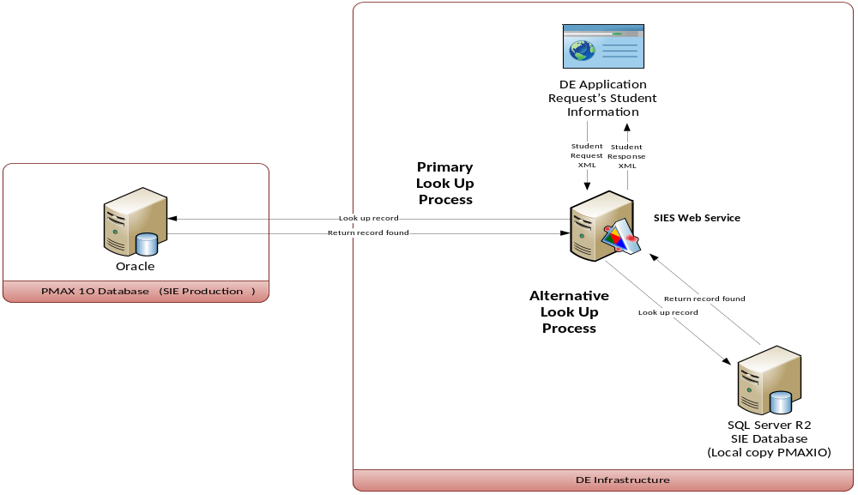
Since the availability of the SIES Web Service is highly required it has two alternative processes to get student information. The primary source (Primary Lookup Process) is the SIE application database that is hosted in an Oracle server, if for any reason the primary source is not available; it will run a second look up process (Alternate Lookup Process) against a local copy of the SIE data, which is stored in a SQL Server 2008 R2 with the most recent information since the last database update process. The database update process is expected to run in a daily basis.
SIES Web Service database update process:

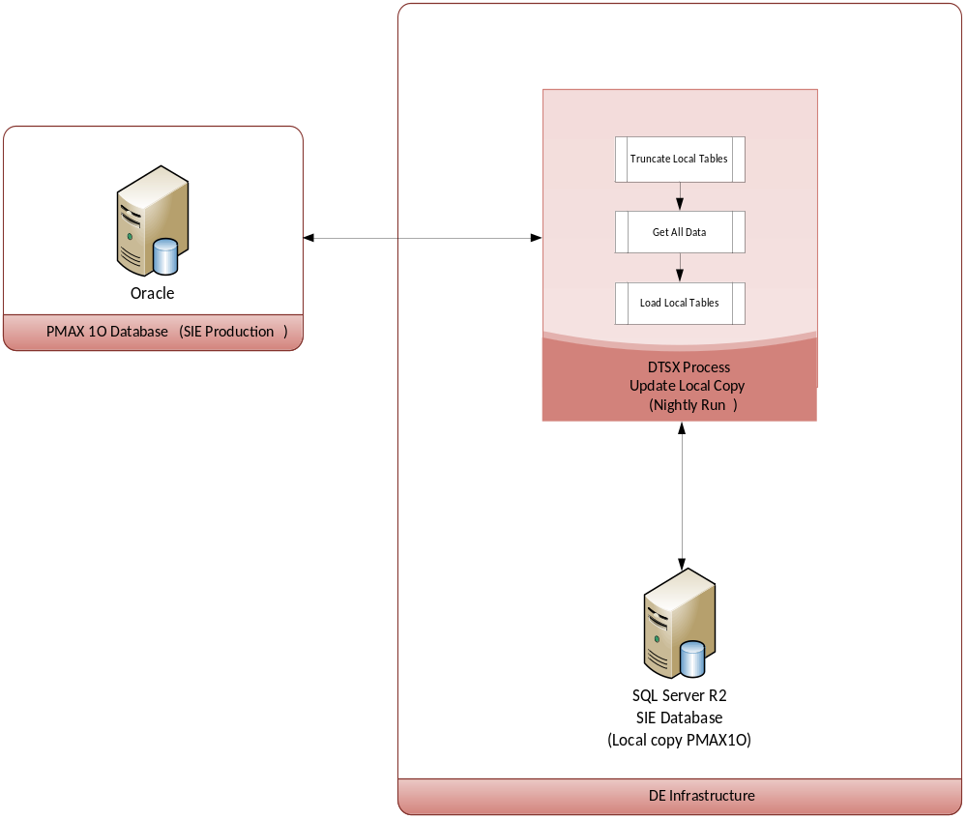

To provide the most recent data in the local SIE database there is a temporary table (*_TEMP) for each view in the Oracle PRDE_WS schema. The actual DTSX process first truncates all temporary tables and loads them with the data from Oracle. An after all temporary table has been loaded successfully, and then the actual tables are loaded from the temporary tables.
These are the SIE database temporary table’s definition:
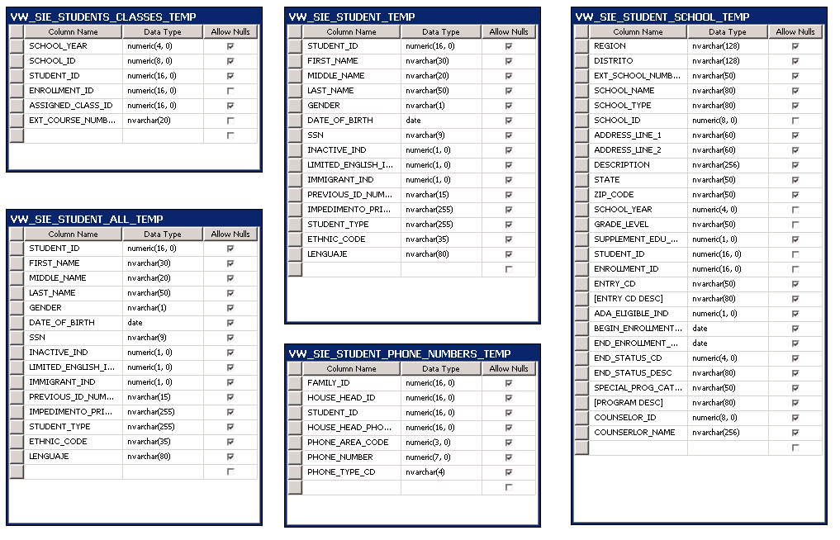
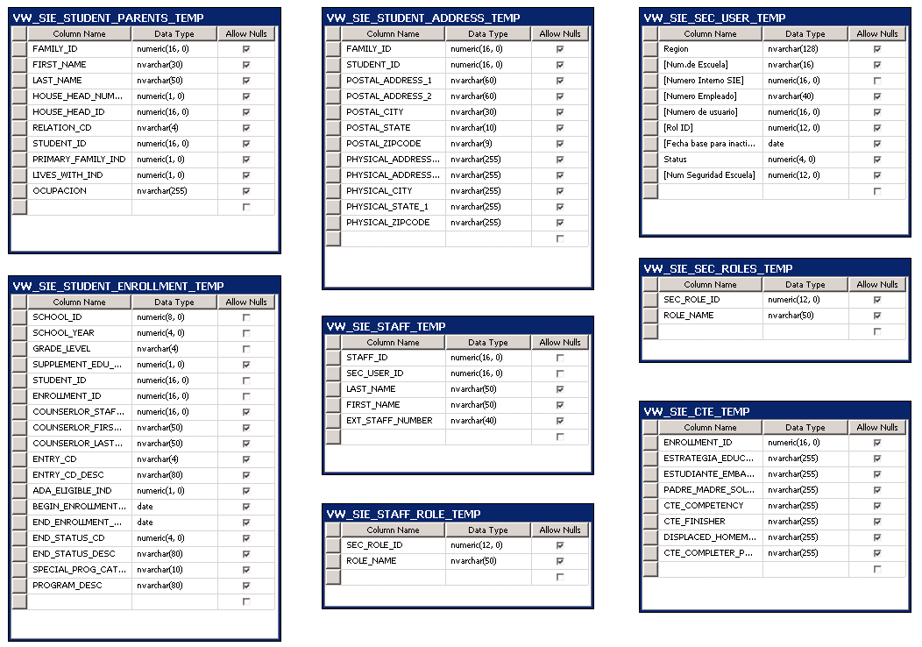
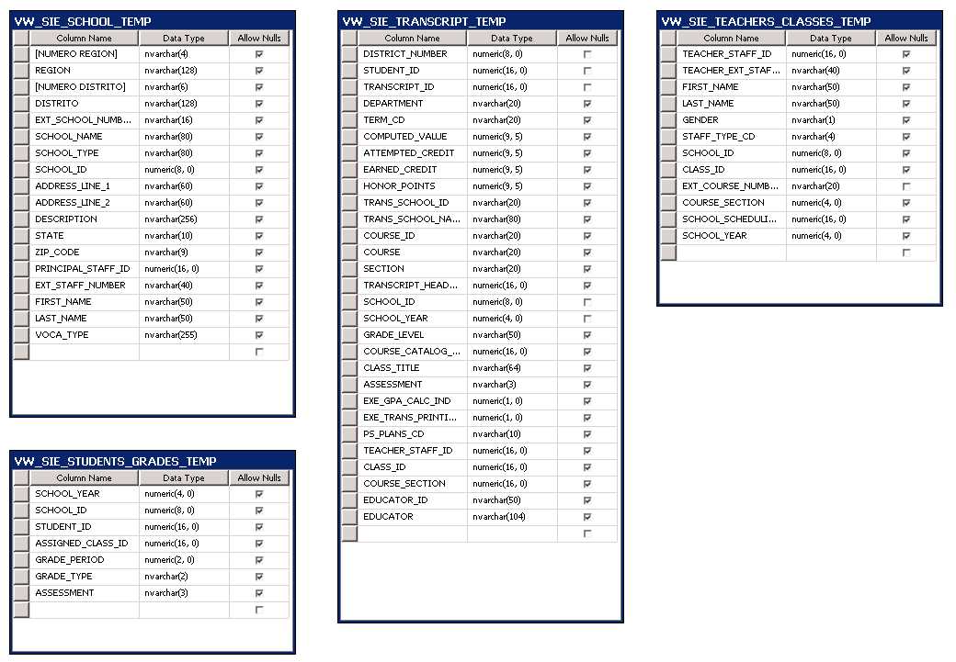
These are the SIE database data table’s definition:
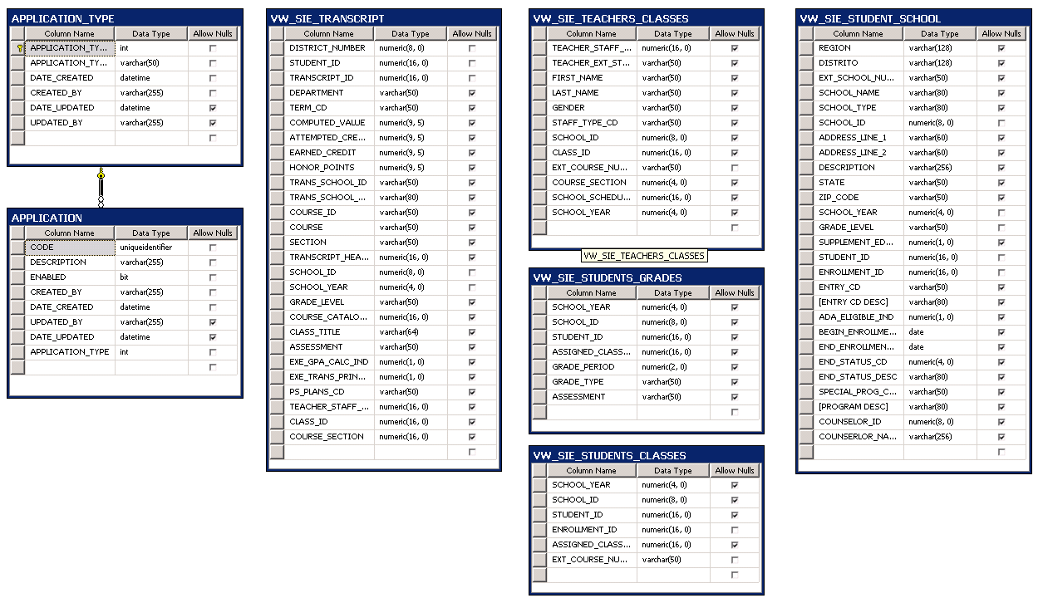
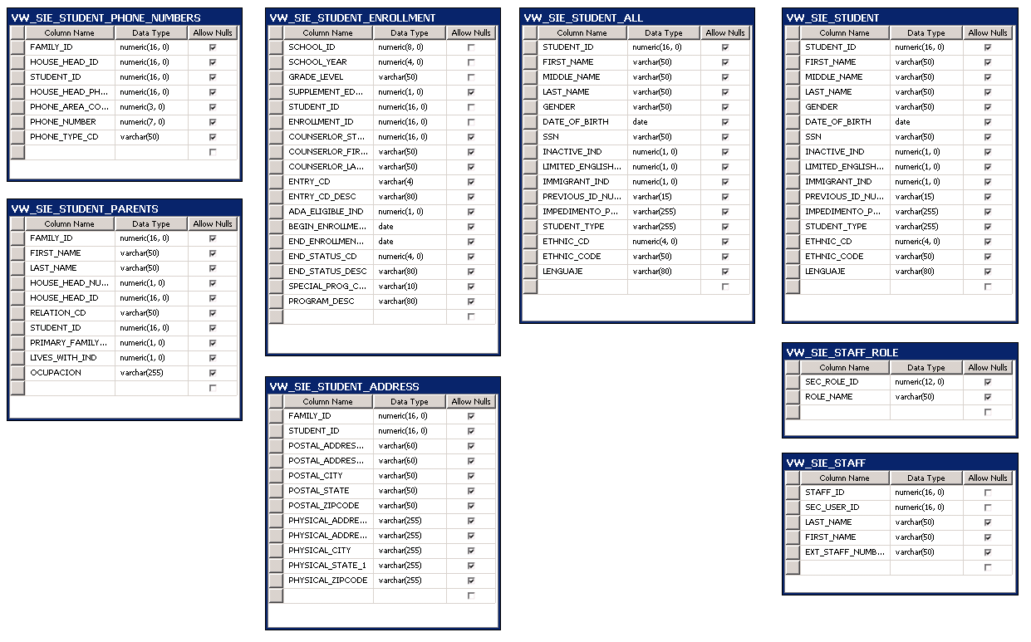
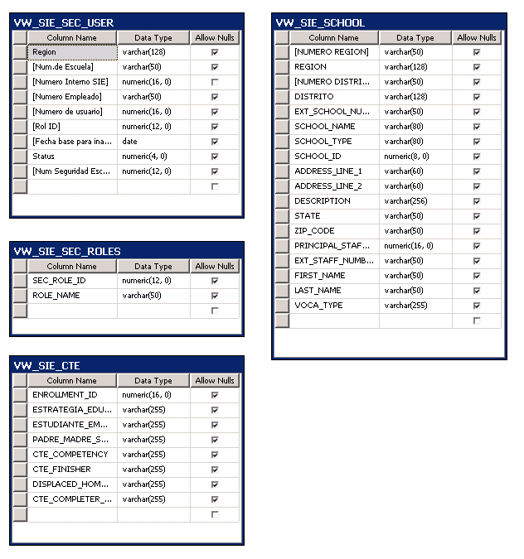

SIES Web Service security uses two methods to validate each application prior it requests student information details.

- First method is validated through the IIS granted IP address allowed for accessing the web service.
- Second method checks if the Application Code, parameter required in the Request XML message, is a valid record in the SIE database table Application.
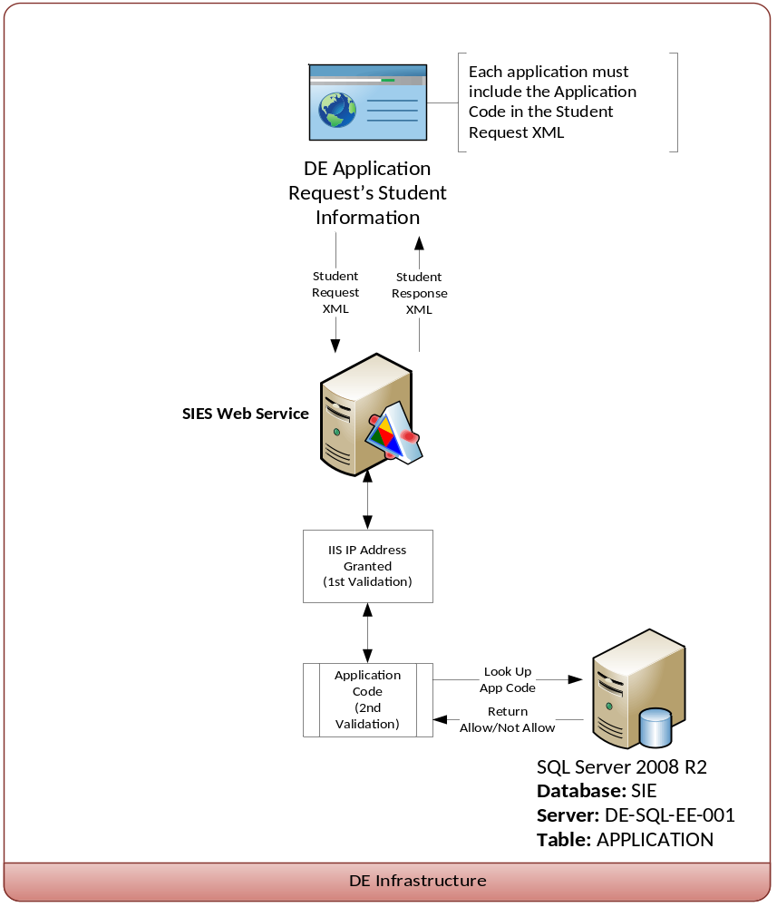

Applications codes tables:
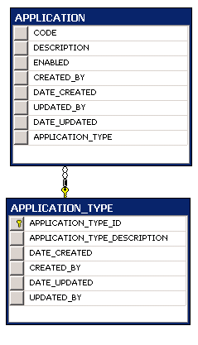
Application’s data rows:
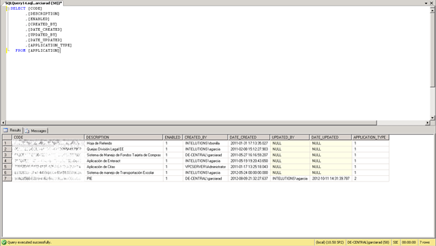
The SIES Web Service has the following operations:

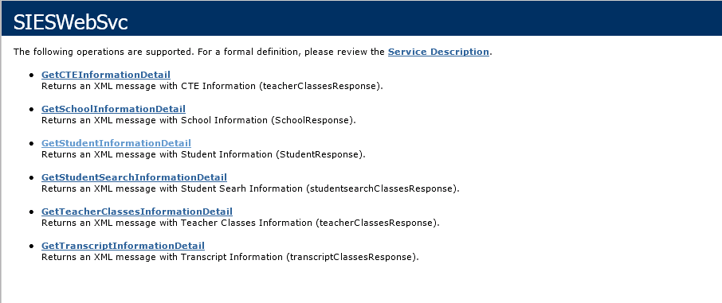

Provide a summary of the contents of the Logical Design document. This should include a succinct statement of the contents of each of the key sections of the document (Users, Objects, Attributes, and so on).
For some projects, it may be appropriate to include the entire contents of the design document, if a choice has been made to consolidate all technical documentation into a large central document.
  - Student Request XML Message
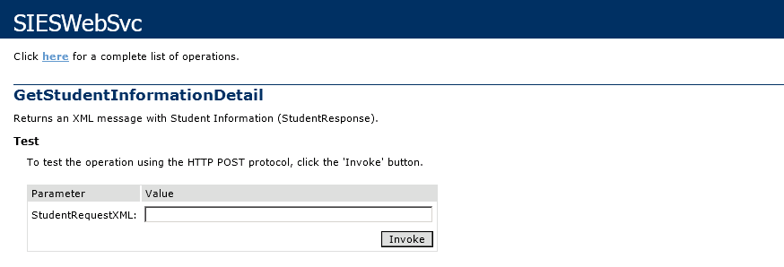
This message represents the information of the student that will be submitted to the SIES Service for its processing. In this context this information is used to process the look up of the student demographic information. The Student Request is an XML document that contains the parameters needed for the search of the student information process. The XML document below represents a sample instance of a Student Request message:
<StudentRequest>
<ApplicationCode></ApplicationCode>
<StudentIdentifierNumber></StudentIdentifierNumber>
<AcademicYear></AcademicYear>
</StudentRequest>
The different sections in the XML message represent different kind of information needed along the student information for processing. Some of this information is required depending on the needs of the application’s request. The following table describes each one of the elements that comprise the Student Request message.

Name | Type | Required | Description
StudentRequest |  | Yes | Element containing the student request information.
ApplicationCode | String | Yes | Element containing the application code that requests the student information.
StudentIdentifierNumber | String | Yes | Element containing the student SIE number.
SchoolYear | String | No | Element containing the student school year value.

  - Student Response XML Message
This message represents the information of the student that will be returned or responded from the SIES Service to the requesting application. In this context this information is used to return the student demographic information needed by the application that request it. The Student Response is an XML document that contains all the detail information of a student. The XML document below represents a sample instance of a Student Response message:
<StudentResponse>
<RequestValues>
<ApplicationCode></ApplicationCode>
<StudentIdentifierNumber></StudentIdentifierNumber>
<SchoolYear></SchoolYear>
</RequestValues>
<ErrorInformation>
<Code></Code>
<Description></Description>
</ErrorInformation>
<StudentDetail>
<Name>
<FirstName></FirstName>
<MiddleName></MiddleName>
<LastName/></LastName>
</Name>
<StudentAddress>
<PhysicalAddress>
<Address1></Address1>
<Address2></Address2>
<City></City>
<State></State>
<ZipCode></ZipCode>
</PhysicalAddress>
<PostalAddress>
<Address1></Address1>
<Address2></Address2>
<City></City>
<State></State>
<ZipCode></ZipCode>
</PostalAddress>
</StudentAddress>
<Contact>
<HomePhone></HomePhone>
<MobilePhone></MobilePhone>
<OtherPhone></OtherPhone>
</Contact>
<Schools>
<School>
<SchoolAddress>
<Address1></Address1>
<Address2></Address2>
<City></City>
<State></State>
<ZipCode></ZipCode>
</SchoolAddress>
<EffectiveStarDate></EffectiveStarDate>
<EffectiveEndDate></EffectiveEndDate>
<ADAIndicator></ADAIndicator>
<GradeLevel></GradeLevel>
<SchoolYear></SchoolYear>
<Name></Name>
<Type></Type>
<IdNumber></IdNumber>
<ExtNumber></ExtNumber>
<District></District>
<Region></Region>
<EnrollmentEndStatus></EnrollmentEndStatus>
<EnrollmentEndStatusDescription></Enro..>
<EnrollmentID></EnrollmentID>
<SupplementEduSvcInd></SupplementEduSvcInd>
<CounselorId></CounselorId>
<CounserlorFirstName></CounserlorFirstName>
<CounserlorLastName></CounserlorLastName>
<EntryCd></EntryCd>
<EntryCdDesc></EntryCdDesc>
<SpecialProgCategoryCd></SpecialProg..>
<ProgramDesc></ProgramDesc>
</School>
</Schools>
<Parents>
<Parent>
<FamilyId></FamilyId>
<FirstName></FirstName>
<LastName></LastName>
<HouseHeadNumber></HouseHeadNumber>
<HouseHeadId></HouseHeadId>
<RelationCd></RelationCd>
<PrimaryFamilyIndicator></PrimaryFamilyIndic..>
<LivesWithIndicator></LivesWithIndicator>
</Parent>
</Parents>
<SchoolYear></SchoolYear>
<StudentId></StudentId>
<Gender></Gender>
<DateOfBirth></DateOfBirth>
<SSN></SSN>
<InactiveIndicator></InactiveIndicator>
<LimitedEnglishIndicator></LimitedEnglishIndicator>
<ImmigrantIndicator></ImmigrantIndidcator>
<PrimaryImpediment></PrimaryImpediment>
<EthnicCode></EthnicCode>
<Language></Language>
<StudentType></StudentType>
</StudentDetail>
</StudentResponse>

Name | Type | Required | Description
StudentResponse |  | Yes | Element containing the student response information.
RequestValues |  | Yes | Element containing the student request information.
ApplicationCode | String | Yes | Element containing the application code that was sent through the StudentRequest.
StudentIdentifierNumber | String | Yes | Element containing the student SIE number that was sent through the StudentRequest.
SchoolYear | String | No | Element containing the student school year that was sent through the StudentRequest.
ErrorInformation |  | Yes | Element containing the student request information.
ErrorCode | String | Yes | Element containing the error code that was generated.
ErrorDescription | String | Yes | Element containing the error description.
StudentDetail |  | Yes | Element containing the student detail information.
SchoolYear | String | Yes | Element containing the student’s school year.
StudentId | String | Yes | Element containing the student’s Id.
Gender | String | Yes | Element containing the student’s gender.
DateOfBirth | String | Yes | Element containing the student’s date of birth.
SSN | String | Yes | Element containing the student’s social security number.
InactiveIndicator | String | Yes | Element containing the student’s inactive indicator. (0 = active; 1 = inactive)
LimitedEnglishIndicator | String | Yes | Element containing if the student has limited English language limitations. (In PR is Spanish limited language skills. 0 = no limitation; 1 = limitation)
InmigrantIndicator | String | Yes | Element containing if the student is immigrant or not. (0 = not immigrant; 1 = inmigrant)
PrimaryImpediment | String | Yes | Element containing if the student has impediment, this element will have impediment, otherwise it will be blank. (If there an impediment it means is an student of the Special Education)
EthnicCode | String | Yes | Element containing the student’s ethnic code. (Values: Nativo Hawaiano/Islas del Pacífico; Asiatico; Indio Americano/Nativo de Alaska; Blanco no Hispano; Puertorriqueño; Negro o Afroamericano; Hispano no Puertorriqueño)
Language | String | Yes | Element containing the student’s language.
StudentType | String | Yes | Element containing the student type. (Values: Público, Privado or NA).
Name |  | Yes | Element containing the applicant’s name information.
FirstName | String | Yes | Student’s first name.
MiddleInitial | String | No | Student’s middle initial.
LastName | String | Yes | Student’s last name.
Address |  | Yes | Element containing the student’s address information.
PhysicalAddress1 | String | Yes | Physical address first line.
PhysicalAddress2 | String | Yes | Physical address second line.
PhysicalCity | String | Yes | Physical address city.
PhysicalState | String | Yes | Physical address state.
PhysicalZipCode | String | Yes | Physical address zip code.
PostalAddress1 | String | Yes | Postal address first line.
PostalAddress2 | String | Yes | Postal address second line.
PostalCity | String | Yes | Postal address city.
PostalState | String | Yes | Postal address state.
PostalZipCode | String | Yes | Postal address zip code.
Contact |  | Yes | Element containing the student’s contact information.
HomePhone | String | Yes | Student’s home phone number.
MobilePhone | String | Yes | Student’s mobile phone number.
OtherPhone | String | Yes | Student’s other phone number.
Schools |  | Yes | Element containing the student’s schools collection information.
School |  | Yes | Element containing the student’s school information.
EffectiveStartDate | String | Yes | School’s effective start date of the student.
EffectiveEndDate | String | Yes | School’s effective end date of the student.
ADAIndicator | String | Yes | School’s indicator if equals one (1) means is the primary school. The student can have more than one school for a school year.
GradeLevel | String | Yes | School grade level.
Name | String | Yes | School’s name.
Type | String | Yes | School’s type.
IdNumber | String | Yes | School’s Id number.
ExtNumber | String | Yes | School’s extension number.
District | String | Yes | School’s district.
Region | String | Yes | School’s region.
EnrollmentEndStatus | String | Yes | School enrollment status code for the student during the effective start date and effective end date.
EnrollmentEndStatus  Description | String | Yes | School enrollment status description for the student during the effective start date and effective end date.
EnrollmentID | String | Yes | School enrollment id for the student.
SupplementEduSvcInd | String | Yes | Element containing if the student is receiving supplement educational services in this school. (0 = not receiving; 1 = receiving)
PhysicalAddress1 | String | Yes | Physical address first line.
PhysicalAddress2 | String | Yes | Physical address second line.
PhysicalCity | String | Yes | Physical address city.
PhysicalState | String | Yes | Physical address state.
PhysicalZipCode | String | Yes | Physical address zip code.
CounselorId | String | Yes | School CounselorId.
CounserlorFirstName | String | Yes | School CounserlorFirstName.
CounserlorLastName | String | Yes | School CounserlorLastName.
EntryCd | String | Yes | School EntryCd.
EntryCdDesc | String | Yes | School EntryCdDesc.
SpecialProgCategoryCd | String | Yes | School SpecialProgCategoryCd.
ProgramDesc | String | Yes | School ProgramDesc.
Parents |  | Yes | Element containing the student’s parents collection information.
Parent |  | Yes | Element containing the each parent information.
FamilyId | String | Yes | Parent’s family id number.
FirstName | String | Yes | Parent’s first name.
LastName | String | Yes | Parent’s last name.
HouseHeadNumber | Integer | Yes | Parent’s family position.
HouseHeadId | Integer | Yes | Parent’s family id.
RelationCd | String | Yes | Parent’s family relationship with the student. Madre MDRE  Encargado ENCA  Cónyuge/Pareja CNYG  Otro OTRO  Padre PDRE  Mismo MSMO
PrimaryFamilyIndicator | String | Yes | Parent’s family indicator. (1 = immediate family)
LiveWithIndicator | String | Yes | Student lives with family indicator. (1 = lives with family; 0 = does not live with family)

  - School Request XML Message
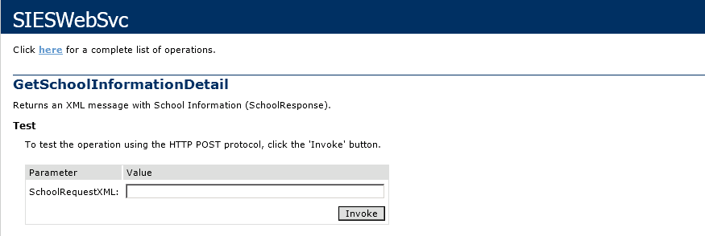
This message represents the information of the student that will be submitted to the SIES Service for its processing. In this context this information is used to process the look up of the School information. The School Request is an XML document that contains the parameters needed for the search of the School information process. The XML document below represents a sample instance of a School Request message:
<SchoolRequest>
<ApplicationCode></ApplicationCode>
<SchoolId></SchoolId>
</SchoolRequest>
The different sections in the XML message represent different kind of information needed along the student information for processing. Some of this information is required depending on the needs of the application’s request. The following table describes each one of the elements that comprise the School Request message.

Name | Type | Required | Description
SchoolRequest |  | Yes | Element containing the school request information.
ApplicationCode | String | Yes | Element containing the application code that requests the student information.
SchoolId | String | Yes | Element containing the SchoolId.

  - School Response XML Message
This message represents the information of the school that will be returned or responded from the SIES Service to the requesting application. In this context this information is used to return the school demographic information needed by the application that requests it. The school Response is an XML document that contains all the detail information of a school. The XML document below represents a sample instance of a school Response message:
<SchoolResponse>
<RequestValues>
<ApplicationCode></ApplicationCode>
<SchoolId></SchoolId>
</RequestValues>
<ErrorInformation>
<Code></Code>
<Description></Description>
</ErrorInformation>
<Schools>
<SchoolDetail>
<RegionId></RegionId>
<RegionName></RegionName>
<DistrictId></DistrictId>
<DistrictName></DistrictName>
<SchoolNumber></SchoolNumber>
<SchoolName></SchoolName>
<SchoolId></SchoolId>
<Address>
<Address1></Address1>
<Address2></Address2>
<City></City>
<State></State>
<ZipCode></ZipCode>
</Address>
<PrincipalStaffId></PrincipalStaffId>
<PrincipalExtNumber></PrincipalExtNumber>
<PrincipalName>
<FirstName></FirstName>
<MiddleName></MiddleName>
<LastName></LastName>
</PrincipalName>
</SchoolDetail>
<SchoolDetail>
<RegionId></RegionId>
<RegionName></RegionName>
<DistrictId></DistrictId>
<DistrictName></DistrictName>
<SchoolNumber></SchoolNumber>
<SchoolName></SchoolName>
<SchoolId></SchoolId>
<Address>
<Address1></Address1>
<Address2></Address2>
<City></City>
<State></State>
<ZipCode></ZipCode>
</Address>
<PrincipalStaffId></PrincipalStaffId>
<PrincipalExtNumber></PrincipalExtNumber>
<PrincipalName>
<FirstName></FirstName>
<MiddleName></MiddleName>
<LastName></LastName>
</PrincipalName>
</SchoolDetail>
<SchoolDetail>
<RegionId></RegionId>
<RegionName></RegionName>
<DistrictId></DistrictId>
<DistrictName></DistrictName>
<SchoolNumber></SchoolNumber>
<SchoolName></SchoolName>
<SchoolId></SchoolId>
<Address>
<Address1></Address1>
<Address2></Address2>
<City></City>
<State></State>
<ZipCode></ZipCode>
</Address>
<PrincipalStaffId></PrincipalStaffId>
<PrincipalExtNumber></PrincipalExtNumber>
<PrincipalName>
<FirstName></FirstName>
<MiddleName></MiddleName>
<LastName></LastName>
</PrincipalName>
</SchoolDetail>
</Schools>
</SchoolResponse>
Name | Type | Required | Description
SchoolResponse |  | Yes | Element containing the school response information.
RequestValues |  | Yes | Element containing the school request information.
ApplicationCode | String | Yes | Element containing the application code that was sent through the schoolRequest.
SchoolId | String | Yes | Element containing the school number that was sent through the schoolRequest.
ErrorInformation |  | Yes | Element containing the school request information.
ErrorCode | String | Yes | Element containing the error code that was generated.
ErrorDescription | String | Yes | Element containing the error description.
SchoolDetail |  | Yes | Element containing the school detail information.
RegionID | String | Yes | Element containing the school region.
RegionName | String | Yes | Element containing the region description.
DistrictId | String | Yes | Element containing the District Id
DistrictName | String | Yes | Element containing District Description
SchoolNumber | String | Yes | Element containing the Extension school number
SchoolName | String | Yes | Element containing the school name
SchoolId | String | Yes | Element containing the school Id
PrincipalStaffId | String | Yes | Element containing the school principal staff id
PrincipalExtNumber | String | Yes | Element containing the school principal ext number.
PrincipalName |  | Yes | Element containing the principal name information.
FirstName | String | Yes | Principal’s first name.
MiddleInitial | String | No | Principal’s middle initial.
LastName | String | Yes | Principal’s last name.
Address |  | Yes | Element containing the school’s address information.
Address1 | String | Yes | Physical address first line.
Address2 | String | Yes | Physical address second line.
City | String | Yes | Physical address city.
State | String | Yes | Physical address state.
ZipCode | String | Yes | Physical address zipcode.
  - CTE Request XML Message
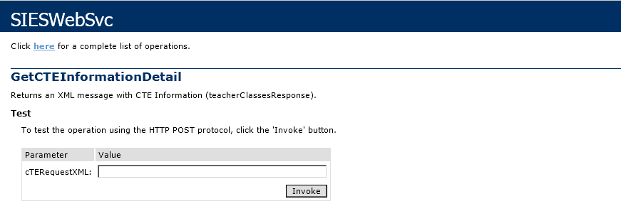
This message represents the information of the student that will be submitted to the SIES Service for its processing. In this context this information is used to process the look up of the CTE information. The CTE Request is an XML document that contains the parameters needed for the search of the CTE information process. The XML document below represents a sample instance of a CTE Request message:
<CTERequest>
<ApplicationCode></ApplicationCode>
<EnrollmentId></EnrollmentId>
</CTERequest>
The different sections in the XML message represent different kind of information needed along the student information for processing. Some of this information is required depending on the needs of the application’s request. The following table describes each one of the elements that comprise the CTE Request message.

Name | Type | Required | Description
CTERequest |  | Yes | Element containing the CTE request information.
ApplicationCode | String | Yes | Element containing the application code that requests the cte information.
EnrollmentId | String | Yes | Element containing the EnrollmentId.

  - CTE Response XML Message
This message represents the information of the Student Program that will be returned or responded from the SIES Service to the requesting application. In this context this information is used to return the Student Program information needed by the application that requests it. The CTE Response is an XML document that contains all Student Program information of a student. The XML document below represents a sample instance of a CTE Response message:
<CTEResponse>
<RequestValues>
<ApplicationCode></ApplicationCode>
<EnrollmentId></EnrollmentId>
</RequestValues>
<ErrorInformation>
<Code></Code>
<Description></Description>
</ErrorInformation>
<CTEs>
<CTEDetail>
<EnrollmentId></EnrollmentId>
<EducationalStrategy></EducationalStrategy>
<PregnantStudent></PregnantStudent>
<SingleFatherMother></SingleFatherMother>
<CTECompetency></CTECompetency>
<ClassProgram></ClassProgram>
<CTEFinisher></CTEFinisher>
<DisplacedHomemaker></DisplacedHomemaker>
</CTEDetail>

Name | Type | Required | Description
CTEResponse |  | Yes | Element containing the CTE response information.
RequestValues |  | Yes | Element containing the CTE request information.
ApplicationCode | String | Yes | Element containing the application code that was sent through the cteRequest.
EnrollmentId | String | Yes | Element containing the enrollment id that was sent through the cteRequest.
ErrorInformation |  | Yes | Element containing the school request information.
ErrorCode | String | Yes | Element containing the error code that was generated.
ErrorDescription | String | Yes | Element containing the error description.
CTEDetail |  | Yes | Element containing the cte detail information.
EnrollmentId | String | Yes | Element containing the Enrollment Id.
EducationalStrategy | String | Yes | Element containing the Educational Strategy.
PregnantStudent | String | Yes | Element containing Pregnant Student.
SingleFatherMother | String | Yes | Element containing Single Father Mother
CTECompetency | String | Yes | Element containing Competency.
ClassProgram | String | Yes | Element containing Class Program.
CTEFinisher | String | Yes | Element containing Finisher.
DisplacementHomemaker | String | Yes | Element containing Displacement Home Maker.

  - Teacher Class Request XML Message
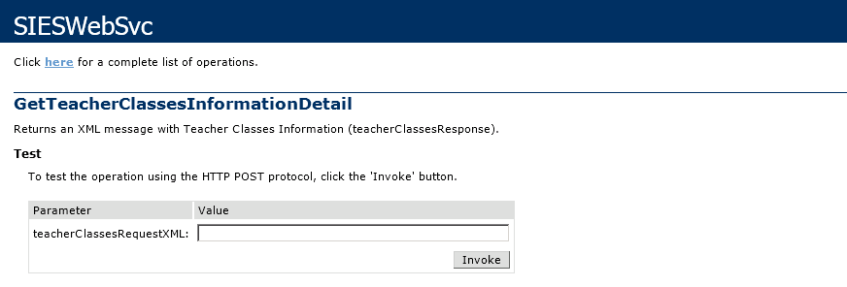
This message represents the information of the student that will be submitted to the SIES Service for its processing. In this context this information is used to process the look up of the TeacherClass information. The TeacherClass Request is an XML document that contains the parameters needed for the search of the TeacherClass information process. The XML document below represents a sample instance of a TeacherClass Request message:
<TeacherCRequest>
<ApplicationCode></ApplicationCode>
<StaffId></StaffId>
</TeacherCRequest>
The different sections in the XML message represent different kind of information needed along the student information for processing. Some of this information is required depending on the needs of the application’s request. The following table describes each one of the elements that comprise the TeacherClass Request message.

Name | Type | Required | Description
TeacherCRequest |  | Yes | Element containing the teacher class request information.
ApplicationCode | String | Yes | Element containing the application code that requests the teacher class information.
StaffId | String | Yes | Element containing the StaffId.

  - Teacher Class Response XML Message
This message represents the information of the Teacher Classes that will be returned or responded from the SIES Service to the requesting application. In this context this information is used to return the Teacher Classes information needed by the application that requests it. The Teacher Class Response is an XML document that contains all Teacher Classes. The XML document below represents a sample instance of a Teacher Class Response message:
<TeacherClassResponse>
<RequestValues>
<ApplicationCode></ApplicationCode>
<StaffId></StaffId>
<SchoolYear></SchoolYear>
</RequestValues>
<ErrorInformation>
<Code></Code>
<Description></Description>
</ErrorInformation>
<TeacherClasses>
<TeacherClassDetail>
<StaffId></StaffId>
<StaffNumber></StaffNumber>
<Name>
<FirstName></FirstName>
<MiddleName></MiddleName>
<LastName></LastName>
</Name>
<Gender></Gender>
<StaffType></StaffType>
<SchoolId></SchoolId>
<ClassId></ClassId>
<CourseNumber></CourseNumber>
<CourseSection></CourseSection>
<SchoolSchedulingParamId></SchoolSchedulingParamId>
<SchoolYear></SchoolYear>
</TeacherClassDetail>
</TeacherClasses>
</TeacherClassResponse>
Name | Type | Required | Description
TeacherClassResponse |  | Yes | Element containing the TeacherClass response information.
RequestValues |  | Yes | Element containing the TeacherClass request information.
ApplicationCode | String | Yes | Element containing the application code that was sent through the TeacherClassRequest.
StaffId | String | Yes | Element containing the Staff id that was sent through the TeacherClassRequest.
ErrorInformation |  | Yes | Element containing the school request information.
ErrorCode | String | Yes | Element containing the error code that was generated.
ErrorDescription | String | Yes | Element containing the error description.
TeacherClassDetail |  | Yes | Element containing the TeacherClass detail information.
StaffId | String | Yes | Element containing the Staff Id.
StaffNumber | String | Yes | Element containing Staff Number.
Name |  | Yes | Element containing the Teacher name information.
FirstName | String | Yes | Teacher’s first name.
MiddleInitial | String | No | Teacher’s middle initial.
LastName | String | Yes | Teacher’s last name.
Gender | String | Yes | Element containing Gender.
StaffType | String | Yes | Element containing Staff Type.
SchoolId | String | Yes | Element containing School Id.
ClassId | String | Yes | Element containing Class Id.
CourseNumber | String | Yes | Element containing Course Number.
CourseSection | String | Yes | Element containing Course Section.
SchoolSchedulingParamId | String | Yes | Element containing School Scheduling Param Id.
SchoolYear | String | Yes | Element containing School Year.

  - Transcript Request XML Message
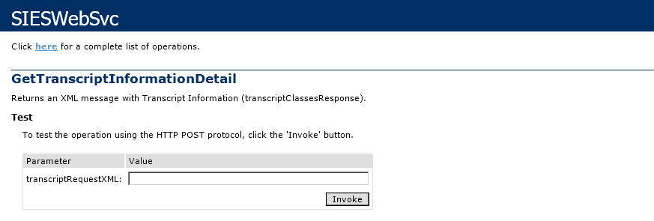
This message represents the information of the student that will be submitted to the SIES Service for its processing. In this context this information is used to process the look up of the Transcript information. The Transcript Request is an XML document that contains the parameters needed for the search of the Transcript information process. The XML document below represents a sample instance of a Transcript Request message:
<TranscriptRequest>
<ApplicationCode></ApplicationCode>
<StudentId></StudentId >
</TranscriptRequest>
The different sections in the XML message represent different kind of information needed along the student information for processing. Some of this information is required depending on the needs of the application’s request. The following table describes each one of the elements that comprise the Transcript Request message.

Name | Type | Required | Description
TranscriptRequest |  | Yes | Element containing the student transcript request information.
ApplicationCode | String | Yes | Element containing the application code that requests the student transcript information.
StudentId | String | Yes | Element containing the StudentId.

  - Transcript Response XML Message
This message represents the information of the Transcript that will be returned or responded from the SIES Service to the requesting application. In this context this information is used to return the Transcript information needed by the application that requests it. The Transcript Response is an XML document that contains all Transcript information. The XML document below represents a sample instance of a Transcript Response message:

<TranscriptResponse>
<RequestValues>
<ApplicationCode></ApplicationCode>
<StudentId></StudentId>
<SchoolYear></SchoolYear>
</RequestValues>
<ErrorInformation>
<Code></Code>
<Description></Description>
</ErrorInformation>
<Transcripts>
<TranscriptDetail>
<DistrictNumber></DistrictNumber>
<StudentId></StudentId>
<TranscriptId></TranscriptId>
<DistrictName></DistrictName>
<Department></Department>
<Term></Term>
<NoteValue>NoteValue1</NoteValue>
<CreditsAttempted></CreditsAttempted>
<CreditsEarned></CreditsEarned>
<HonorPointsByClass></HonorPointsByClass>
<TransSchoolId></TransSchoolId>
<TransSchoolName></TransSchoolName>
<CourseId></CourseId>
<CourseName></CourseName>
<Section></Section>
<EducatorId></EducatorId>
<EducatorName></EducatorName>
<TrasncriptHeaderId></TrasncriptHeaderId>
<SchoolId></SchoolId>
<SchoolYear></SchoolYear>
<GradeLevel></GradeLevel>
<ClassTitle></ClassTitle>
<FinalNote></FinalNote>
<ExeGPACalcInd></ExeGPACalcInd>
<ExeTransPrintingInd></ExeTransPrintingInd>
<PlansCd></PlansCd>
</TranscriptDetail>
</Transcripts>
</TranscriptResponse>

Name | Type | Required | Description
TranscriptResponse |  | Yes | Element containing the Transcript response information.
RequestValues |  | Yes | Element containing the Transcript request information.
ApplicationCode | String | Yes | Element containing the application code that was sent through the TranscriptRequest.
StudentId | String | Yes | Element containing the Student Id that was sent through the TranscriptRequest.
SchoolYear | String | Yes | Element containing the School Year that was sent through the TranscriptRequest.
ErrorInformation |  | Yes | Element containing the school request information.
ErrorCode | String | Yes | Element containing the error code that was generated.
ErrorDescription | String | Yes | Element containing the error description.
TranscriptDetail |  | Yes | Element containing the transcript detail information.
DistrictNumber | String | Yes | Element containing the District Number.
StudentId | String | Yes | Element containing Student Id.
TranscriptId |  | Yes | Element containing the Transcript Id.
DistrictName | String | Yes | Element containing the District Name.
Department | String | No | Element containing Department.
Term | String | Yes | Element containing Term.
NoteValue | String | Yes | Element containing Note Value.
CreditsAttempted | String | Yes | Element containing Credits Attempted.
CreditsEarned | String | Yes | Element Credits Earned.
HonorPointsByClass | String | Yes | Element containing Honor Points By Class.
TransSchoolId | String | Yes | Element containing Transcript School Id.
TransSchoolName | String | Yes | Element containing Transcript School Name.
CourseId |  |  | Element containing Transcript Course Id.
CourseName | String | Yes | Element containing Course Name.
Section | String | Yes | Element containing Section.
EducatorId | String | Yes | Element containing Educator Id.
EducatorName | String | Yes | Element containing Educator Name.
TrasncriptHeaderId | String | Yes | Element containing Transcript Header Id
SchoolId | String | Yes | Element containing School Id.
SchoolYear | String | Yes | Element containing School Year.
GradeLevel | String | Yes | Element Grade Level.
ClassTitle | String | Yes | Element containing Class Title.
FinalNote | String | Yes | Element containing Final Note.
ExeGPACalcInd | String | Yes | Element containing Exe GPA Calc Ind.
ExeTransPrintingInd | String | Yes | Element containing Exe Trans Printing Ind.
PlansCd | String | Yes | Element containing Plans Cd.

  - Student Search Request XML Message
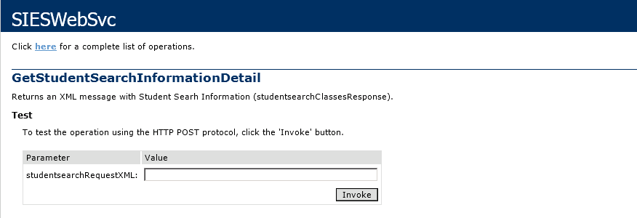
This message represents the information of the student that will be submitted to the SIES Service for its processing. In this context this information is used to process the look up of the Student Search information. The Student Search Request is an XML document that contains the parameters needed for the search of the Student Search information process. The XML document below represents a sample instance of a Student Search Request message:
<StudentSearchListRequest>
<ApplicationCode></ApplicationCode>
<FirstName></FirstName>
<LastName></LastName>
<BirthDate></BirthDate>
<Impediment></Impediment>
<SchoolCode></SchoolCode>
</StudentSearchListRequest>
The different sections in the XML message represent different kind of information needed along the student information for processing. Some of this information is required depending on the needs of the application’s request. The following table describes each one of the elements that comprise the Student Search Request message.

Name | Type | Required | Description
StudentRequest |  | Yes | Element containing the student request information.
ApplicationCode | String | Yes | Element containing the application code that requests the student information.
FirstName | String | Yes | Element containing the FirstName Idt hat was sent through the StudentSearchList Request.
LastName | String | Yes | Element containing the LastName that was sent through the StudentSearchList Request.
BirthDate | String | Yes | Element containing the BirthDate that was sent through the StudentSearchList Request.
Impediment | String | Yes | Element containing the Impediment that was sent through the StudentSearchList Request.
SchoolCode | String | Yes | Element containing the SchoolCode that was sent through the StudentSearchList Request.

  - Student Search Response XML Message
This message represents the information of the Student Search that will be returned or responded from the SIES Service to the requesting application. In this context this information is used to return the Student Search information needed by the application that requests it. The Student Search Response is an XML document that contains all Student Search information. The XML document below represents a sample instance of a Student Search Response message:

<StudentSearchListResponse>
<RequestValues>
<ApplicationCode></ApplicationCode>
<FirstName></FirstName>
<LastName></LastName>
<BirthDate>BirthDate1</BirthDate>
<Impediment></Impediment>
<SchoolCode></SchoolCode>
</RequestValues>
<ErrorInformation>
<Code></Code>
<Description></Description>
</ErrorInformation>
<StudentSearchList>
<StudentSearchListDetail>
<StudentId></StudentId>
<Name></Name>
<Impediment></Impediment>
<SchoolName></SchoolName>
</StudentSearchListDetail>
<StudentSearchListDetail>
<StudentId></StudentId>
<Name></Name>
<Impediment></Impediment>
<SchoolName></SchoolName>
</StudentSearchListDetail>
<StudentSearchListDetail>
<StudentId></StudentId>
<Name></Name>
<Impediment></Impediment>
<SchoolName></SchoolName>
</StudentSearchListDetail>
</StudentSearchList>
</StudentSearchListResponse>
Name | Type | Required | Description
StudentSearchListResponse |  | Yes | Element containing the StudentSearchList response information.
RequestValues |  | Yes | Element containing the StudentSearchList request information.
ApplicationCode | String | Yes | Element containing the application code that was sent through the StudentSearchList Request.
FirstName | String | Yes | Element containing the FirstName that was sent through the StudentSearchList Request.
LastName | String | Yes | Element containing the LastName that was sent through the StudentSearchList Request.
BirthDate | String | Yes | Element containing the BirthDate that was sent through the StudentSearchList Request.
Impediment | String | Yes | Element containing the Impediment that was sent through the StudentSearchList Request.
Schoolcode | String | Yes | Element containing the Schoolcode that was sent through the StudentSearchList Request.
ErrorInformation |  | Yes | Element containing the school request information.
ErrorCode | String | Yes | Element containing the error code that was generated.
ErrorDescription | String | Yes | Element containing the error description.
StudentSearchListDetail |  | Yes | Element containing the StudentSearchList detail information.
StudentId | String | Yes | Element containing Student Id.
Name | String | Yes | Element containing the Student Name.
Impediment | String | No | Element containing the Student Impediment.
School Name | String | Yes | Element containing School Name.

  - Error Messages

In case an error is generated during the process of the look up of student information, the SIES Web Service will return the StudentResponse with RequestValues and ErrorInformation with the error details, and the StudentDetail elements will be left in blank. The same process works for CTEResponse, SchoolResponse, TeacherClassResponse, TranscriptResponse and StudentSearchListResponse.

Example:

<StudentResponse>
<RequestValues>
<ApplicationCode>{AEUI13-…}</ApplicationCode>
<StudentIdentifierNumber>123456789</StudentIdentifierNum..>
<SchoolYear/>
</RequestValues>
<ErrorInformation>
<Code>E01</Code>
<Description> Application unauthorized to access the SIES Web Service. Please contact the system administrator.
</Description>
</ErrorInformation>
<StudentDetail>
<Name>
<FirstName />
<MiddleName />
<LastName />
</Name>
<StudentAddress>
<PhysicalAddress>
<Address1 />
<Address2 />
<City />
<State />
<ZipCode />
</PhysicalAddress>
<PostalAddress>
<Address1 />
<Address2 />
<City />
<State / >
<ZipCode />
</PostalAddress>
</StudentAddress>
<Contact>
<HomePhone />
<MobilePhone />
<OtherPhone />
</Contact>
<Schools>
<School>
<SchoolAddress>
<Address1 />
<Address2 />
<City />
<State />
<ZipCode />
</SchoolAddress>
<EffectiveStartDate />
<EffectiveEndDate />
<ADAIndicator />
<GradeLevel />
<Name />
<Type />
<IdNumber />
<ExtNumber />
<District />
<Region />
<EnrollmentEndStatus />
<EnrollmentEndStatusDescription />
<EnrollmentID />
<SupplementEduSvcInd />
</School>
</Schools>
<Parents>
<Parent>
<FamilyId />
<FirstName />
<LastName />
<HouseHeadNumber />
<HouseHeadId />
<RelationCd />
<PrimaryFamilyIndicator />
<LivesWithIndicator />
</Parent>
</Parents>
<SchoolYear />
<StudentId />
<Gender />
<DateOfBirth />
<SSN />
<InactiveIndicator />
<LimitedEnglishIndicator />
<ImmigrantIndicator />
<PrimaryImpediment />
<EthnicCode />
<Language />
<StudentType />
</StudentDetail>
</StudentResponse>

  - Error Codes

Code | Description
E01 | Application unauthorized to access the SIES Web Service. Please contact the system administrator.
E02 | Required parameter missing. Verify that all the required parameters are included in the StudentRequest XML message. Like the ApplicationCode and the student SIE number.
E03 | StudentRequest XML message does not have the correct format. Verify that all the XML elements conform to the StudentRequest message.
E04 | Data source systems are unavailable at the moment, try later or contact the system administrator. Another reason could be configuration parameters.
E05 | Student identification number has an invalid format. Remember that only numbers are allowed. Please enter a valid SIE number.
E06 | Student information could not be obtained because the student identification number does not exist or is invalid.
E07 | Length of the application code is incorrect. Make sure that have 36 characters.
E99 | An unknown error has occurred. Please contact the system administrator for further details.

Sie Security System (SieSec)
XML Messages

The Sie Security System (SieSec) XML Messages enable the communication between the systems in the Department of Education and the SIE (“Sistema de Información del Estudiante”) System. These messages serve the main purpose of the communication to validate user accounts from SIE and the applications in the Department of Education. The sections below describe the contents of each one of such message types.

  - SieSec Web Service Overview
In the Department of Education resides the SieSec Web Service that provides the functionality of user accounts validation and return the result to the application that requested the information. The user account validation is processed against the production system SIE (PMAX1O), which is the primary source system. SIES Web Service functions as a communication layer against the SIE system.
The user account validation process uses the .Net System.Security.Cryptography engine to create the hashed passwords. The hash type requirement is SHA1 with the string conversion to Base64. Also an engine to encrypt and decrypt values was incorporated to the Intelutions.Utilities.dll to keep the usernames and password ciphered between each application and SieSec web service. For the encryption engine work properly a cipher key needs to be created in the web.config o app.config of each application that will validate user accounts against the SIE (<add key="CipherKey" value="{ask Sie Administrator for value}"/>). The Intelutions.Utilities.dll is required for the hash and encryption methods.
SieSec Web Service process workflow:
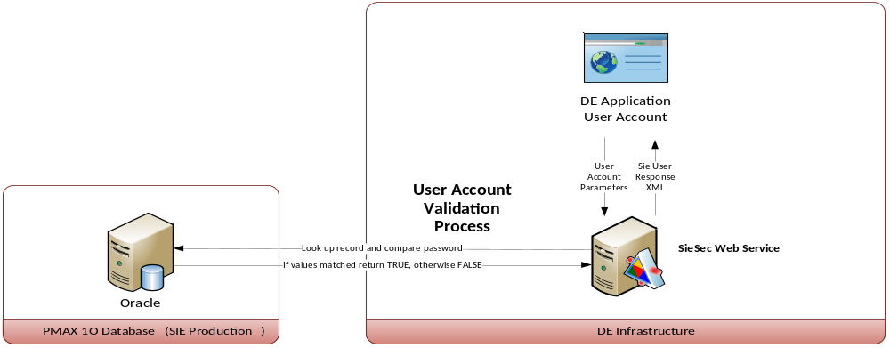
SieSec Web Service security uses two methods to validate each application prior it requests student information details.

- First method is validated through the IIS granted IP address allowed for accessing the web service.
- Second method checks if the Application Code (a parameter required) is a valid record in the SIE database table Application.

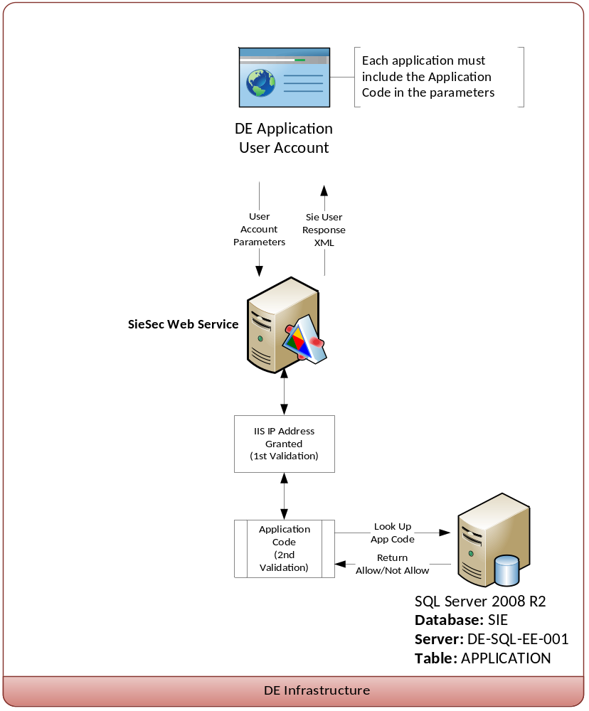
The SieSec Web Service has the following operations:
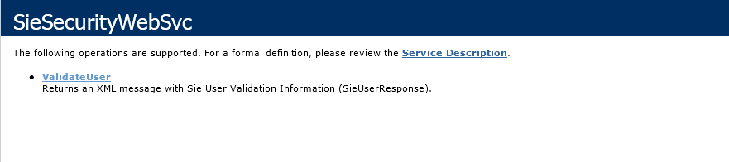
  - User Account Parameters
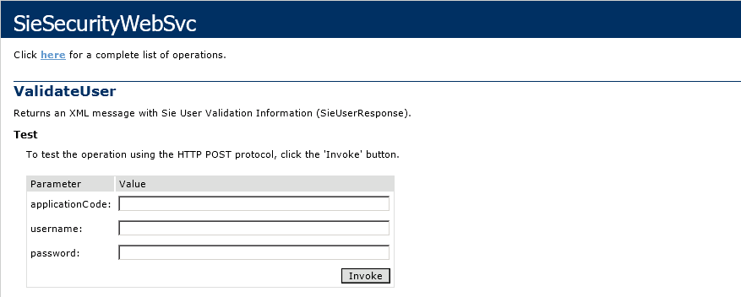
This user account parameters will be submitted to the SieSec Web Service for its processing. In this context the username and password are required to be encrypted or ciphered; otherwise the user account validation will fail. The following table describes each one of the user account parameters.
Name | Type | Required | Description
Parameter
ApplicationCode | String | Yes | Element containing the application code that requests user account validation.
Username | String | Yes | Element containing SIE username. This value must be ciphered.
Password | String | Yes | Element containing SIE password. This value must be ciphered.
  - Sie User Response XML Message
This message represents the information of the user account that will be validated from the SieSec Web Service to the requesting application. In this context this information is used to return TRUE if the user account is authenticated against SIE Oracle security tables, otherwise it will return FALSE to application that request it. The XML document below represents a sample instance of a Sie User Response message:
<SieUserResponse>
<IsValid></IsValid>
<ErrorCode></ErrorCode>
<ErrorDescription></ErrorDescription>
</SieUserResponse>

Name | Type | Required | Description
SieUserResponse |  | Yes | Element containing the student response information.
IsValid | String | Yes | Element containing the value TRUE or FALSE depending on the validation of the user account.
ErrorCode | String | Yes | Element containing the error code that was generated.
ErrorDescription | String | Yes | Element containing the error description.

  - Error Messages

In case an error is generated during the process of the user account validation, the SieSec Web Service will return the SieUserResponse with the error details.
Example:
<SieUserResponse>
<IsValid>FALSE</IsValid>
<ErrorCode>E01</ErrorCode>
<ErrorDescription> Application unauthorized to access the SIES
Web Service. Please contact the system administrator.
</ErrorDescription>
</SieUserResponse>
  - Error Codes

Code | Description
E01 | Application unauthorized to access the SIES Web Service. Please contact the system administrator.
E04 | Data source systems are unavailable at the moment, try later or contact the system administrator. Another reason could be configuration parameters.
E10 | Required parameter missing or invalid parameters. Verify that all the required and valid parameters are included in the request.
E11 | Authentication failed. Invalid username or password. Please enter the correct information.
E95 | Systems data sources are unavailable at this moment. Please try again later or contact the system administrator.
E98 | Error connection to Oracle.
E99 | An unknown error has occurred. Please contact the system administrator for further details.

Sie Web Services IP Address Restriction

The SIE Web Service application includes a security validation by IP. By default the SIE Web Service has deny all restriction only allowing the specified IP’s in the server configuration. This is managed and configured in the IIS of the server DE-WEB-EE-001. Admin rights are required to execute these tasks.
- Open de Remote Desktop Client on your computer.
- Enter the IP or Server name and click connect, in this case is DE-WEB-EE-001 or 192.168.22.245.
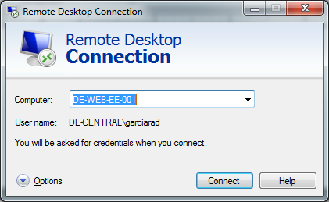
- Click Start -> Administrative Tools -> Internet Information Services (IIS) Manager
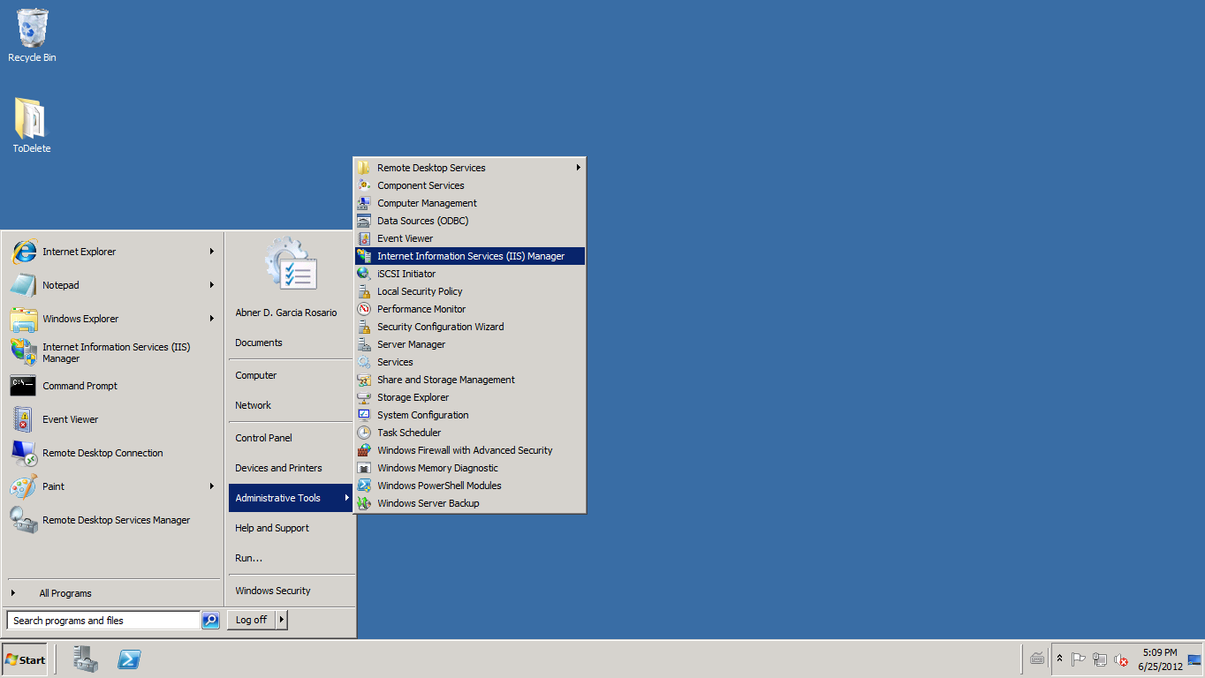
Open the Default Web site and go to the SIEWS web application.
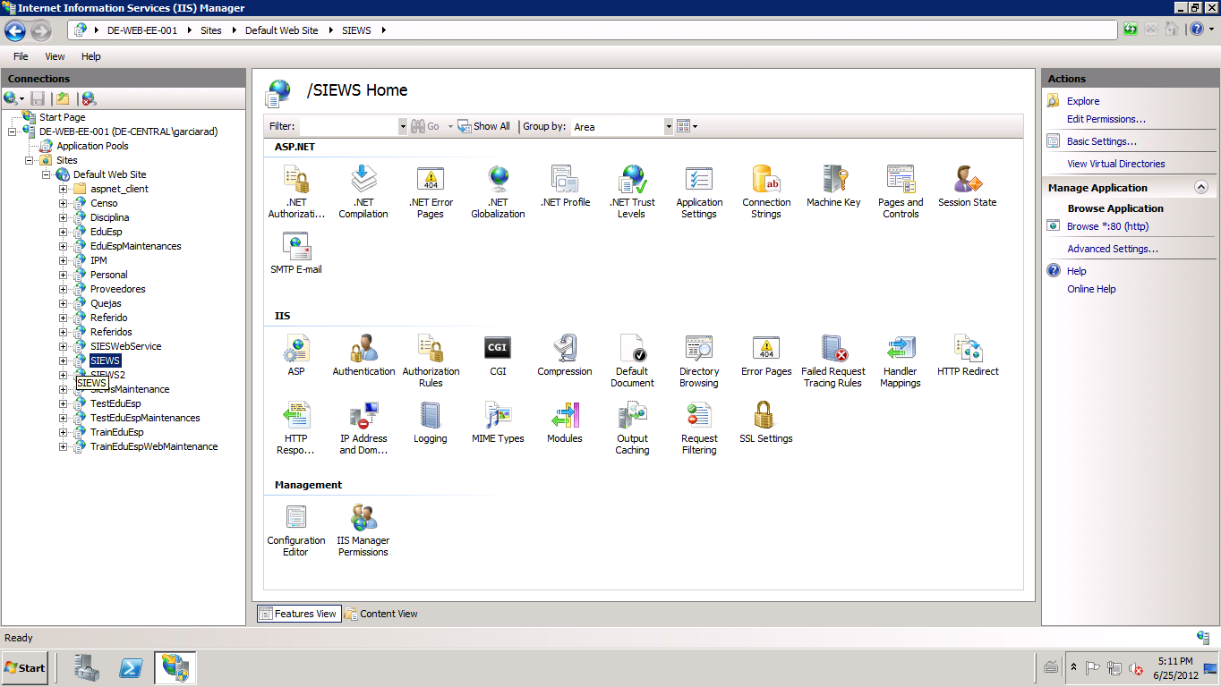
- To the right pane on the same window go to the “IP Address and Domain Restrictions” and double click it to open the feature.
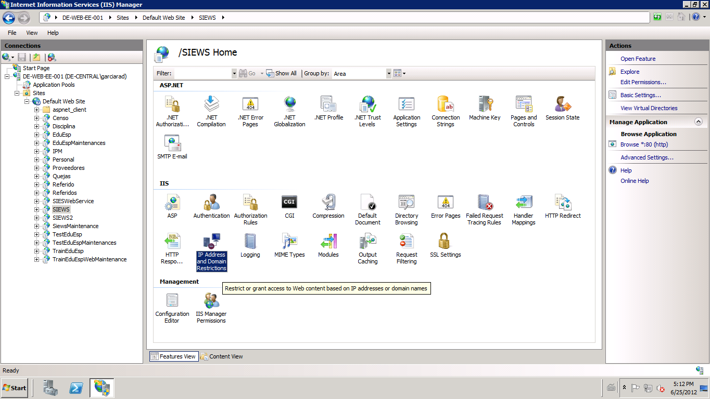

- Go the Actions pane on the top-right part of the window and click Add Allow Entry:
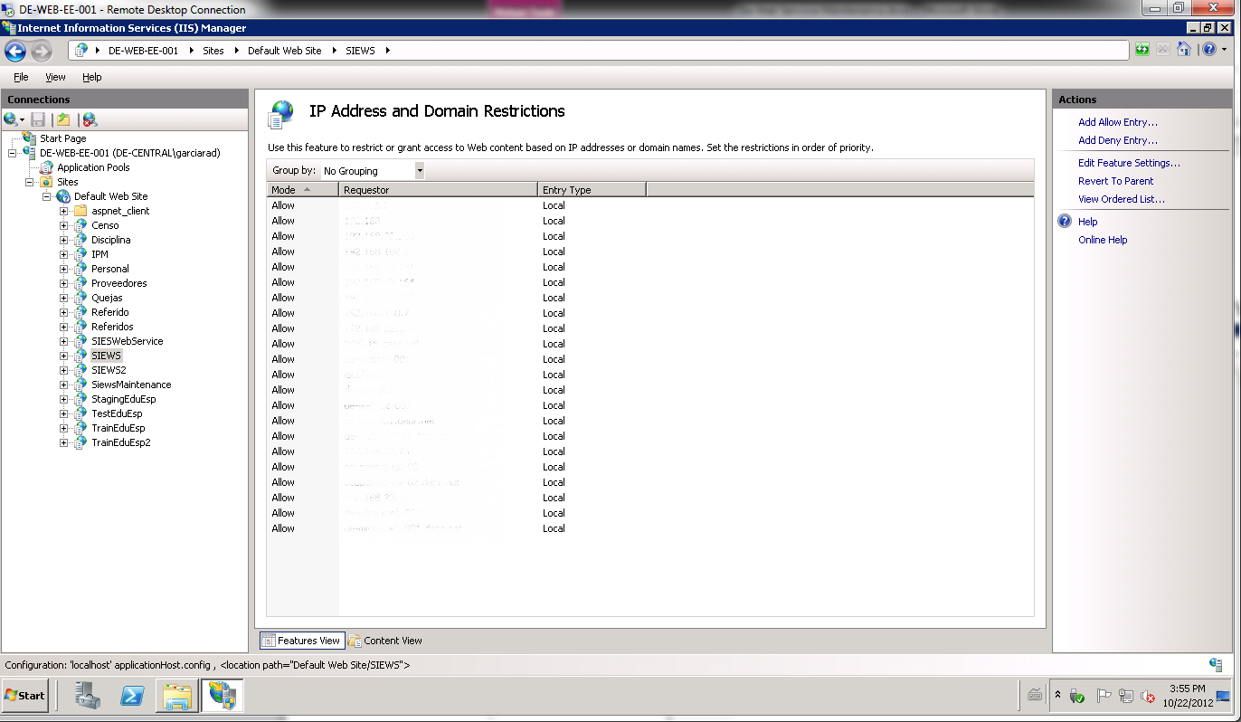
- Enter IP address or domain name and then click OK.
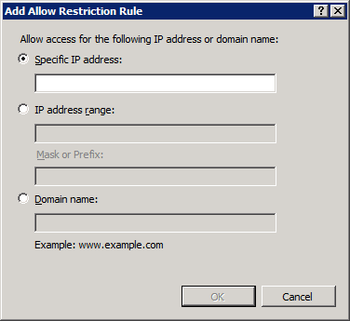
- Now the allow rule for the IP is created. To add more rules just repeat steps 5-7 as needed.
- Once completed LOG-OFF from the server.
- Done

Sie Web Services Application’s Access

This web application maintains the information for each application that has access to the SIE Web Service. In this web maintenance you can add, edit and delete the different application codes.
  - Add Application
- Open the IE 9 (or above) explorer browser and go to the following URL: http://de-web-ee-001/siewsmaintenance/
- The web application will ask for your credentials:
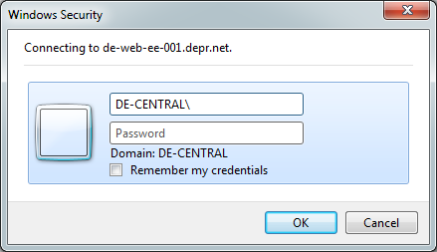
You need to enter your domain user account and password.
- Once the main page loads you will see the actual application codes available on the system.
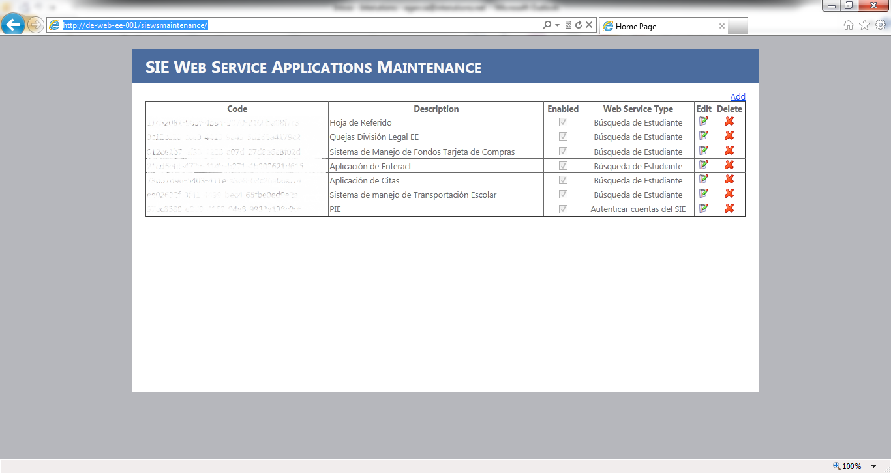
- Click the Add link on the right corner of the web page.
- Enter the name of the Application on the Description Field and select the Web Service Type application. Then click Save link.
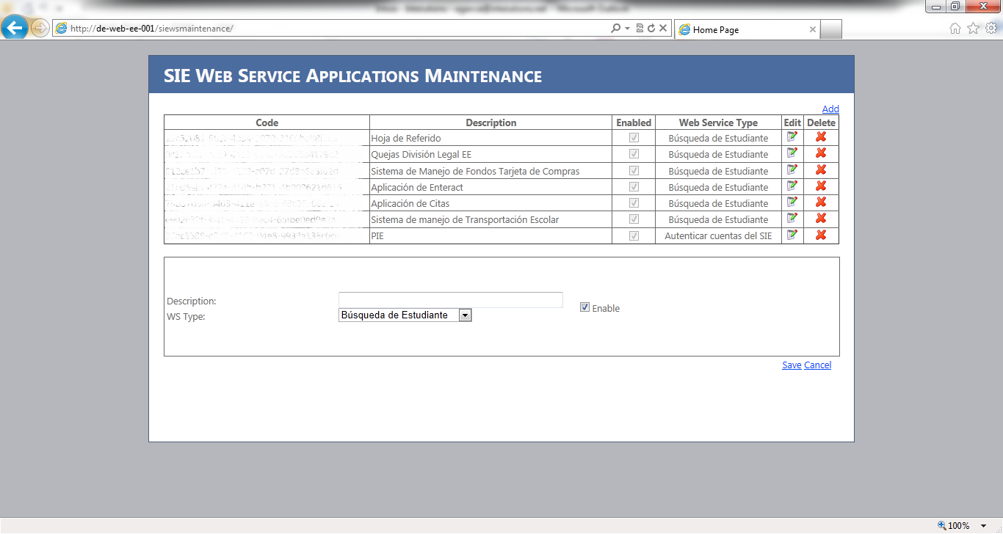
- Then you should see the record created with NEW application code. NOTE: on each addition a NEW code will be generated.
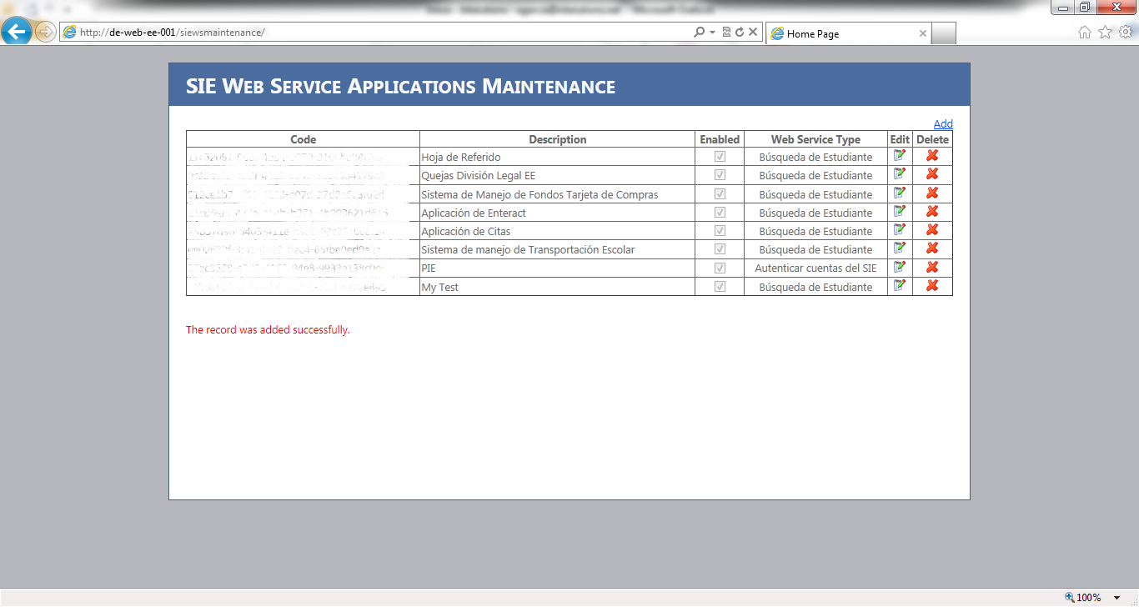
- Done

  - Edit Application
- Open the IE 9 (or above) explorer browser and go to the following URL: http://de-web-ee-001/siewsmaintenance/
- The web application will ask for your credentials:
You need to enter your domain user account and password.
- Once the main page loads you will see the actual application codes available on the system.
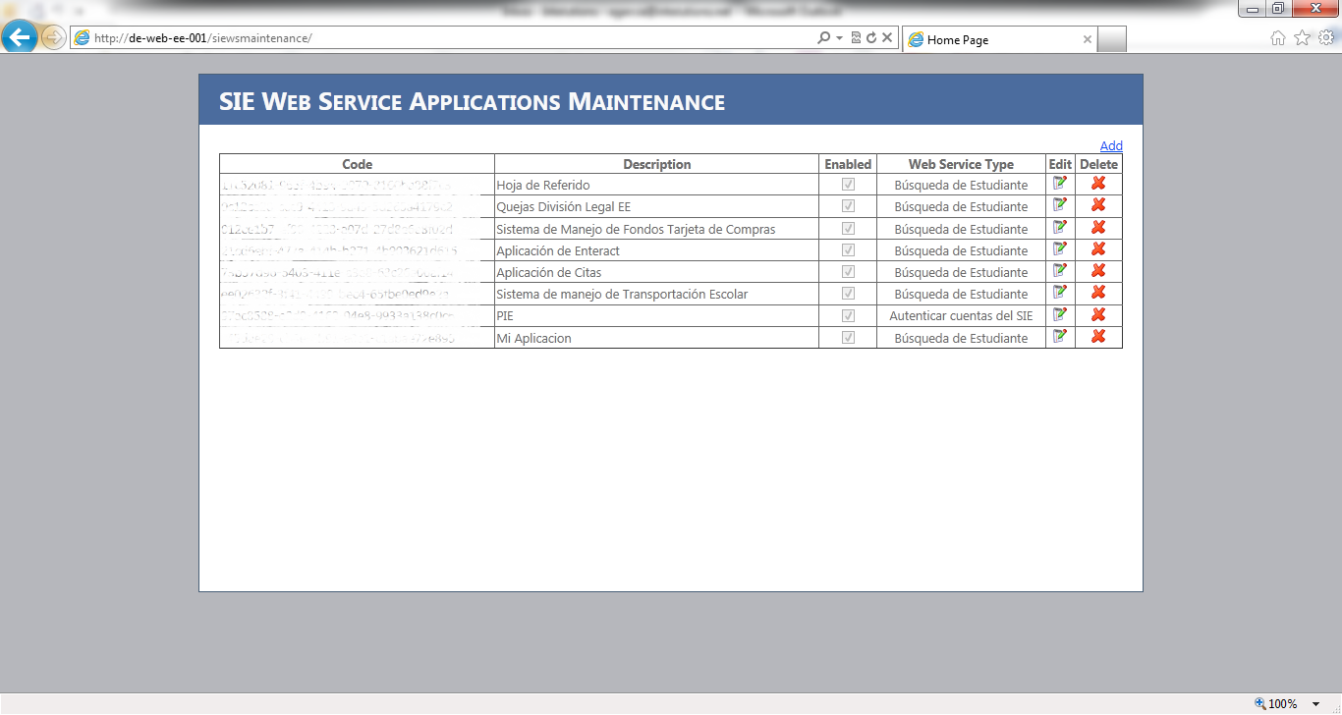
- Click on the edit button on the desired record.

- The edit pane will appear with the information of the record you want to edit. Once changed click the Save link.
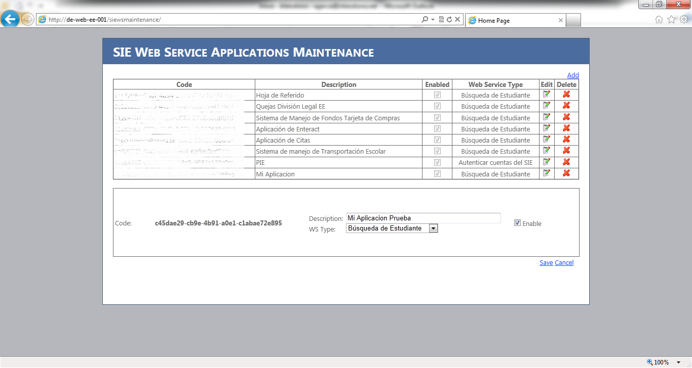
- Done
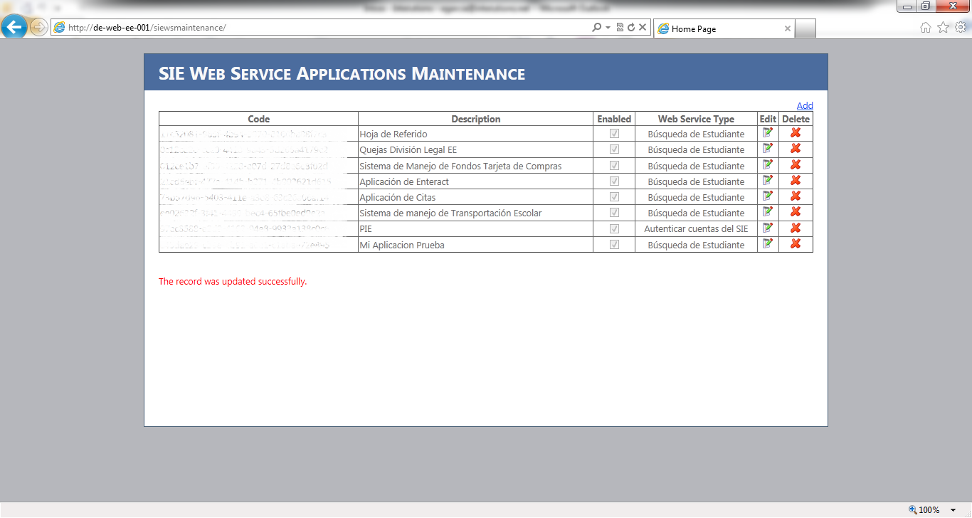

  - Delete Application
- Open the IE 9 (or above) explorer browser and go to the following URL: http://de-web-ee-001/siewsmaintenance/
- The web application will ask for your credentials:
You need to enter your domain user account and password.
- Once the main page loads you will see the actual application codes available on the system.
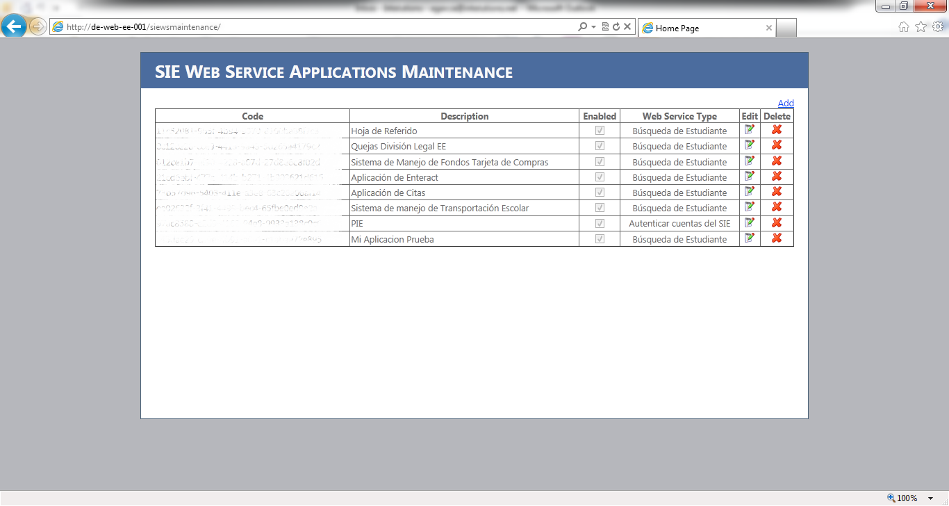

- Click on the delete button on the desired record.

- Final question will appear to challenge the record deletion.
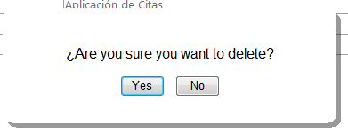
Once you click the Yes button the record will be deleted from the database.
- You should see that the eliminated from the application maintenance page.
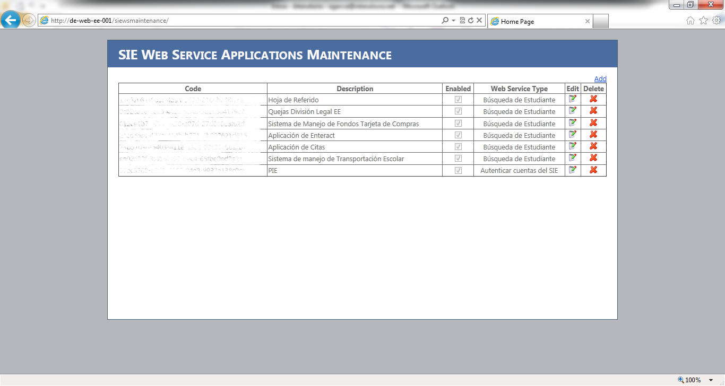
- Done

